press release

TTG TRAVEL EXPERIENCE: THE SUMMER TOURISM SEASON FACES FUEL, COSTS AND SAFETY CHALLENGES
68% OF ITALIANS PLAN TO GO AWAY AT LEAST ONCE

- TTG Italia’s market research analysis: the international context is affecting the travel choices of 62% of Italians. 59% are looking to Italy, 24% to Europe and 17% to intercontinental destinations
- From 14th to 16th October 2026, at Rimini Expo Centre and organised by Italian Exhibition Group, TTG Travel Experience and InOut | The Hospitality Community will bring together destinations, tour operators, travel agencies, airlines, hospitality businesses and international buyers to interpret the market’s new directions

Rimini, 6th July 2026 – While summer has confirmed the Italian population’s desire to travel, a more cautious traveller is studying the market, mindful of the overall cost of a holiday and the reliability of the guarantees on offer. We will know how things panned out at TTG Travel Experience 2026, the Mediterranean’s leading event for global tourism, organised by Italian Exhibition Group and scheduled to take place from 14th to 16th October at Rimini Expo Centre alongside InOut | The Hospitality Community, which will bring the design, services, wellness, technology, outdoor worlds and new forms of hospitality to the exhibition. Indeed, following a tourist season that began against a backdrop of fuel price concerns and geopolitical tensions, TTG will once again be the place where current tourism trends are interpreted as market indicators, fostering dialogue between operators, destinations and businesses across the sector.

SUMMER 2026, TRAVEL IS STILL A PRIORITY, BUT CHOICES ARE CHANGING
Let’s start from the top. According to analyses gathered by TTG Italia and beginning with the Udicon-Istituto Piepoli survey, the international situation will affect this summer’s travel decisions for 62% of Italians, whilst 68% still plan to go away at least once in the coming months. The first impact is on the choice of destination: 59% of those surveyed are opting for domestic destinations, 24% are looking to Europe and 17% are planning an intercontinental trip. Rather than a decline in demand, the market is seeing a shift in preferences driven by cost pressures and uncertainty.
Price is a key factor throughout the entire booking process. To keep costs down, 31% of Italians say they are looking at cheaper accommodation, 27% are choosing closer destinations, 23% are cutting back on restaurants and activities, 19% are travelling in the low season and 18% are opting for shorter stays.
Fuel is still a background issue. The fears circulating in the weeks leading up to the start of the season have been allayed by reassurances from the aviation sector. ENAC has ruled out any supply issues in Europe; ITA Airways has confirmed that summer flights will operate as scheduled and that fares for tickets already booked will remain unchanged; Air France-KLM has indicated positive availability for July and August; Lufthansa has reported no sign of risk at the group’s six European hubs, including Rome. Emirates, Qatar Airways and Vueling have also reassured the market about the gradual return to normal operations and service stability. Fuel availability therefore appears to be under control, whilst the economic issue is still unresolved. Fluctuations in jet fuel costs have already affected prices and commercial planning. For organised tourism, the issue is not only about the operational cost of flights, but also the ability to turn this uncertainty into a reassuring proposition for the end customer. Several operators have therefore decided to introduce price protection schemes and more flexible terms regarding the final cost of the holiday.
But the new geography of demand is also being shaped by the climate. The ‘coolcationing’ phenomenon is encouraging interest in cooler locations with summer mountain holiday destinations offering wellbeing and freedom gaining ground.

TTG TRAVEL EXPERIENCE, THE MARKET WILL BE MEASURED BY THE THEME OF EXIST
As mentioned earlier, the final figures will be revealed at TTG Travel Experience 2026, to be held from 14th to 16th October at Rimini Expo Centre, in its role as the nerve centre for the tourism industry at a time when the sector is having to contend with more cautious travellers and higher holiday value expectations. EXIST, the theme of the 2026 edition of TTG Travel Experience, was chosen precisely to reflect a tourism trend for more authentic experiences, greater awareness and a stronger connection with places, people and the time spent travelling.
Having attracted 2,700 exhibiting brands, 1,000 buyers from 75 countries, 60 start-ups and 400 speakers from institutions, companies and academic facilities, the success of the 2025 edition is further confirmation of the format’s central importance.

ABOUT TTG TRAVEL EXPERIENCE – INOUT | The Hospitality Community
Event: international trade show; organiser: Italian Exhibition Group SpA; frequency: annual; edition: 63rd ; entry: trade only; website: www.ttgexpo.it - #ttgexpo
PRESS CONTACT IEG, TTG TRAVEL EXPERIENCE
Elisabetta Vitali, head of corporate communication & media relation; Marco Forcellini, Pier Francesco Bellini, press office manager media@iegexpo.it
MEDIA AGENCY TTG TRAVEL EXPERIENCE
Martina Vacca: martina@mindthepop.it, mob. +39 339 748 5994; Fabrizio Raimondi: fabrizio@mindthepop.it, mob. +39 335 389 848; Stefano Chiossi: stefano@mindthepop.it, mob. + 39 388 739 4358.

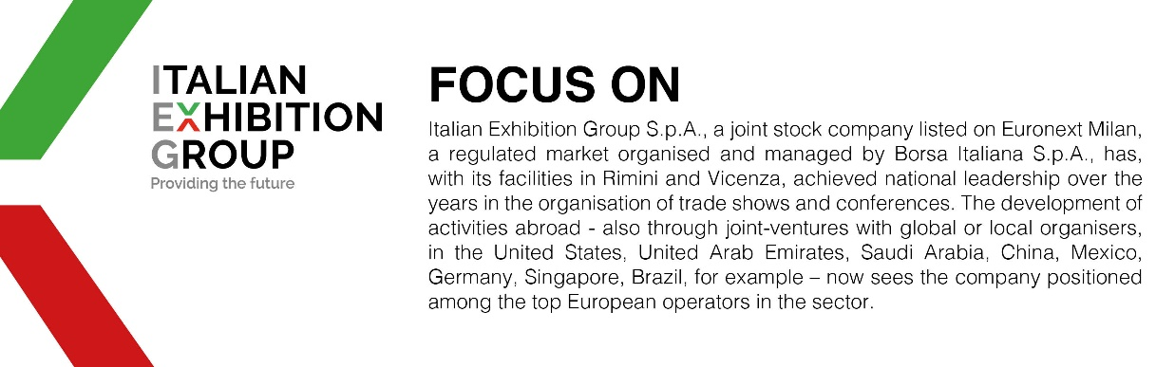

This press release contains forecast elements and estimates that reflect the management´s current opinions (´forward-looking statements´), particularly regarding future management performance, realization of investments, cash flow trends and the evolution of the financial structure. For their very nature, forward-looking statements have a component of risk and uncertainty, as they depend on the occurrence of future events. The effective results may differ (even significantly) from those announced, due to numerous factors, including, only by way of example: food service market and tourist flow trends in Italy, gold and jewellery market trends, green economy market trends; the evolution of raw material prices; general macroeconomic conditions; geopolitical factors and evolutions in the legislative framework. Moreover, the information contained in this release, does not claim to be complete, and has not been verified by independent third parties. Forecasts, estimates and objectives contained herein are based on the information available to the Company as at the date of this release.

