press release
(English translation)

TTG AND INOUT 2025: RIMINI USHERS IN A NEW ERA FOR TOURISM
THE DIRECT ROME-RIMINI FLIGHT HAS ARRIVED, FOLLOWING A 15% INCREASE IN FOREIGN VISITORS IN 2024.
- From October 8 to 10, Rimini TTG Travel Experience and InOut | The Hospitality Community will return, marking the double b2b event for the global tourism industry.
- The theme “Awake To a New Era” leads the 2025 edition of TTG, urging the industry to evolve and embrace digitalisation and the evolving needs of travellers with increasingly smart approaches.
- InOut | The Hospitality Community shines a spotlight on the most advanced solutions for furnishing accommodation spaces blending wellness, sports, and technology.
ttgexpo.it | inoutexpo.it
Rimini (Italy) 12 May 2025 — A new era dawns on the horizon of tourism and hospitality. From October 8 to 10, 2025, TTG Travel Experience and InOut | The Hospitality Community, curated by Italian Exhibition Group, will once again take centre stage at Rimini Expo Centre. This event brings together the entire tourism and hospitality ecosystem in a single, large platform, fostering relationship building, idea generation, and defining the new coordinates of contemporary hospitality.
The central theme of the 62nd edition of the event, “Awake To a New Era”, is more than just a slogan: it's a pressing call to recognise the profound changes that are reshaping global tourism. The post-pandemic world, digital acceleration, and the new demands of travellers who are increasingly seeking authentic, regenerating, and sustainable experiences all require a new mindset.
In this context, TTG Travel Experience and InOut | The Hospitality Community assert themselves as the meeting point for the entire organised tourism industry, where national and international buyers engage in dialogue with tour operators, tourism organisations, destinations, and accommodation facilities. This year's innovations include My Agenda by TTG, an advanced demand-supply matching platform that empowers national and international buyers to connect with Italian and foreign sellers. Additionally, TTG Next Start Up, a district dedicated to young companies, is growing rapidly, revolutionising the industry with technological solutions, sustainable mobility, digital experiences, and innovative service models. To enhance the offer, the event has expanded the areas dedicated to thermal and nautical tourism, as these sectors are experiencing significant growth.
InOut | The Hospitality Community, in perfect synergy with TTG Travel Experience, remains the go-to event for those who design, furnish, and renovate hospitality spaces. Hotels, hotel chains, architects, designers, general contractors, campsites, beach resorts, and construction companies will discover the most advanced solutions for a hospitality experience that prioritises well-being, functionality, and sustainability. The 2025 edition will focus on three main areas: well-being, with two halls dedicated to a holistic approach that integrates wellness, physical and mental regeneration, sports, and food as essential elements of a wellness-focused vacation; sports & fitness, increasingly

present in the modern tourist experience; and technology, the star of smart hospitality designed to simplify life for both guests and managers: one-click check-in and check-out, voice controls in the room, smart home automation, and artificial intelligence for enhanced experience and efficiency.
“The paradigms of the past are no longer sufficient to comprehend the complexity of the present: tourism must evolve. 'Awake To a New Era' symbolises this collective awakening, a new awareness that involves the entire industry, calling for a redefinition of approaches and dynamics in a world that's constantly evolving”, remarks Gloria Armiri, Group Exhibition Manager at TTG Travel Experience and InOut, as she shares her insights on The Hospitality Community.
In this context, the 2025 innovations, from exhibition content to logistics, are integrated. The direct Rome-Rimini air connection, organised by IEG and operated by Luxwing from October 7 to 10, simplifies access to the expo centre for buyers and professionals in the industry, optimising time and business opportunities. This strategic choice supports the growth of foreign presences, which increased by 15% in the last edition, a figure that demonstrates the growing international appeal of TTG and InOut. A new travel option, joining the existing ones, including train travel. The Riminifiera Railway Station, located within the Rimini Expo Centre, is situated on the Milan-Bari line, just 50 metres from the South Entrance and is active during the event days.
ABOUT TTG TRAVEL EXPERIENCE – INOUT | The Hospitality Community
Event type: international event; organiser: Italian Exhibition Group SpA; recurrence: annual; edition: 62nd ; open to: exclusively for professional operators; website: www.ttgexpo.it - #ttgexpo

IEG PRESS CONTACTS, TTG TRAVEL EXPERIENCE
Elisabetta Vitali, head of corporate communication & media relation; Marco Forcellini, Pier Francesco Bellini, press office manager media@iegexpo.it

MEDIA AGENCY TTG TRAVEL EXPERIENCE
Martina Vacca: martina@mindthepop.it, mob. +39 339 748 4994; Fabrizio Raimondi: fabrizio@mindthepop.it, mob. +39 335 389 848; Benedetto Colli: benedetto@mindthepop.it, mob. 380 371 2272; Stefano Chiossi: stefano@mindthepop.it, mob. + 39 388 739 4358.

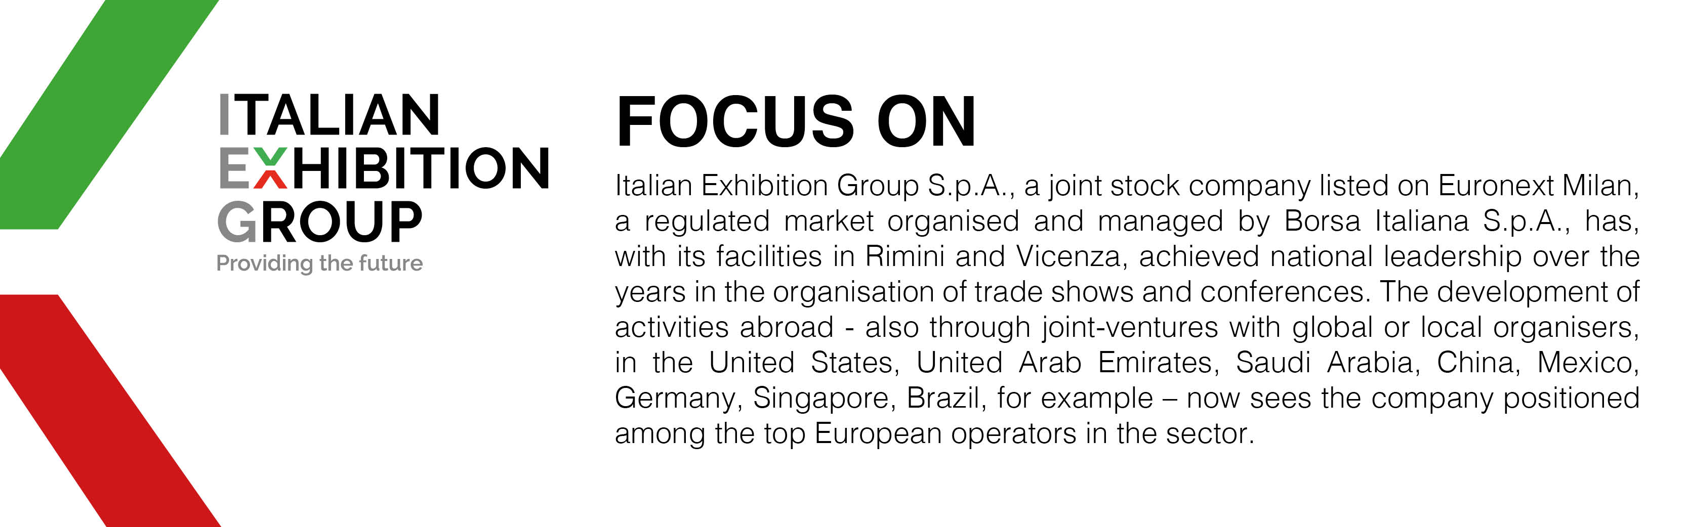

This press release contains forecast elements and estimates that reflect the management’s current opinions (“forward-looking statements”), particularly regarding future management performance, realization of investments, cash flow trends and the evolution of the financial structure. For their very nature, forward-looking statements have a component of risk and uncertainty, as they depend on the occurrence of future events. The effective results may differ (even significantly) from those announced, due to numerous factors, including, only by way of example: food service market and tourist flow trends in Italy, gold and jewellery market trends, green economy market trends; the evolution of raw material prices; general macroeconomic conditions; geopolitical factors and evolutions in the legislative framework. Moreover, the information contained in this release does not claim to be complete, and has not been verified by independent third parties. Forecasts, estimates and objectives contained herein are based on the information available to the Company as at the date of this release.

