Final press release

TTG TRAVEL EXPERIENCE AND INOUT 2025 SET A HIGHER BAR:
ATTENDANCE UP 3%

- The excellent trend of TTG Travel Experience and InOut | The Hospitality Community, curated by Italian Exhibition Group, continues, confirming its status as the largest tourism marketplace.
- The trade fair featured 2,700 brands, 1,000 buyers from 75 countries, and 19,500 business meetings, with 400 speakers participating in 200 talks and conferences, and 700 accredited journalists.
- Strong institutional presence, with regional tourism departments leading discussions and strategies for the industry's development.
- Spotlight on youth and education, with academic institutions driving discussions on tourism professions.
- Aura, an extension of TTG dedicated to high-end travel, was launched in preview and will debut in Florence in 2026.
ttgexpo.it | inoutexpo.it

Rimini, 10 October 2025 – Attendance once again on the rise (+3% compared to 2024) for the 62nd edition of TTG Travel Experience, running parallel with InOut | The Hospitality Community, curated by Italian Exhibition Group (IEG) and concluding today at Rimini Expo Centre. This growth follows a significant and steady trend over the past three years, marked by an increase in overall attendance, visitor quality, and exhibitor satisfaction. This result underscores an industry in full swing and confirms the event's strategic role as an international hub for tourism and hospitality.
For three days, Rimini became the capital of the tourism business, featuring 2,700 exhibiting brands, 1,000 buyers from 75 countries, 60 startups, 400 speakers from institutions, companies, and academia, and 700 accredited journalists.
A dynamic, engaging, and increasingly global edition, which has also seen a significant increase in business opportunities: over 19,500 meetings held on the matching platform, demonstrating the strength of a constantly evolving marketplace.

AWAKE TO A NEW ERA: THE REAWAKENING OF GLOBAL TOURISM
The 2025 theme, "Awake to a New Era," guided the event's narrative, inviting reflection on the ongoing changes. Over 200 events across 7 themed arenas explored the new frontiers of tourism and hospitality, ranging from artificial intelligence to training, and from sustainability to hospitality design. The search for "new rules" in tourism permeated every panel, serving as an invitation to develop transversal skills, integrate ethics with technology, and build business models that anticipate the future. TTG has reaffirmed its international appeal with buyers from 75 countries, including the United States, Canada, the United Kingdom, Germany, India, China, and South America.
The Italian regions showcased the full range of domestic incoming tourism, from villages to trails, from rural landscapes to food and wine tourism. Meanwhile, foreign destinations presented a global panorama of emerging experiential tourism opportunities.

INTRODUCING AURA, THE FUTURE OF HIGH-END TRAVEL
Luxury tourism is one of the fastest-growing segments today: in Italy alone, it is worth over 9 billion euros in direct spending on 5-star and 5-star luxury hotels, accounting for 16.8% of the national hotel revenue (Demoskopika). A sector that extends far beyond art cities, encompassing more authentic and exclusive destinations that attract high-end travellers seeking unique experiences. In this context, TTG remains a benchmark for the entire industry with the Luxury Event by TTG, which hosted over 1,600 business meetings, highlighting Italian expertise in high-end hospitality. A major innovation launched at TTG was Aura, the new event that marks the evolution of the TTG ecosystem and solidifies its leadership as a platform for the entire tourism industry. The event will debut in Florence from October 27 to 29, 2026, as a new international hub dedicated to luxury travel.

THE MINISTER OF TOURISM, DANIELA SANTANCHÈ: "TOURISM IS AN ECONOMIC AND SOCIAL LEVER"
«This year's TTG follows the first WTTC Global Summit hosted in Italy, which confirmed tourism as a strategic lever for growth, employment, and innovation," said Tourism Minister Daniela Santanchè at the event's opening. "This industry, which currently accounts for 13% of the national GDP, will continue to grow significantly over the next ten years». This year, the event's importance was underscored by the strong participation of regional tourism departments, with presence not only through stands but also via numerous conferences, meetings, and discussions focused on strategies to promote the Italian tourism system.

SPACE FOR UNIVERSITIES AND ACADEMIES TO TRAIN THE LEADERS OF FUTURE TOURISM
Universities and tourism academies were key players in this year’s edition, engaging in the Next Start-up Arena to explore youth involvement and career opportunities in tourism. While the industry continues to attract talent, it calls for more structured training and professional development programmes. Promising start-ups and SMEs were also recognised for their innovative contributions.

INOUT: THE FORMAT DEDICATED TO THE HOTELS, BEACHES, AND CAMPSITES
InOut | The Hospitality Community highlighted innovations in hospitality design, services, and furnishings, covering everything from indoor spaces to beach and campsite facilities. Wellness emerged as a central theme in the Poolwide area, measured by the ability to offer comprehensive experiences that integrate self-care, quality nutrition, and psychophysical harmony. From saunas to sensory rituals, and integrating with gastronomic and sports offerings, a vision of wellness tourism emerges that embraces the body, mind, and the local area.

Save the Date – Join Italian Exhibition Group at Rimini Expo Centre, October 14–16, 2026, for the next edition of TTG and InOut.

ABOUT TTG TRAVEL EXPERIENCE – INOUT | The Hospitality Community
Event: international trade show; organiser: Italian Exhibition Group SpA; frequency: annual; edition: 62nd; open to: trade only; website: www.ttgexpo.it www.inoutexpo.it - #ttgexpo

PRESS CONTACT IEG, TTG TRAVEL EXPERIENCE
Elisabetta Vitali, head of corporate communication & media relation; Marco Forcellini, Pier Francesco Bellini, press office manager
media@iegexpo.it
MEDIA AGENCY TTG TRAVEL EXPERIENCE
Martina Vacca: martina@mindthepop.it, mob. +39 339 748 5994; Fabrizio Raimondi: fabrizio@mindthepop.it, mob. +39 335 389 848; Benedetto Colli: benedetto@mindthepop.it, mob. 380 371 2272; Stefano Chiossi: stefano@mindthepop.it, mob. + 39 388 739 4358.
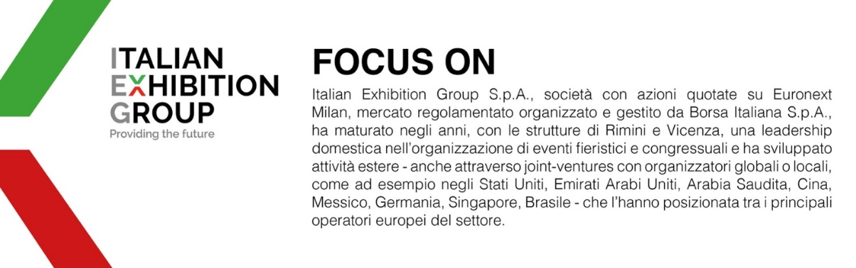
Il presente comunicato stampa contiene elementi previsionali e stime che riflettono le attuali opinioni del management (“forward- looking statements”) specie per quanto riguarda performance gestionali future, realizzazione di investimenti, andamento dei flussi di cassa ed evoluzione della struttura finanziaria. I forward-looking statements hanno per loro natura una componente di rischio ed incertezza perché dipendono dal verificarsi di eventi futuri. I risultati effettivi potranno differire anche in misura significativa rispetto a quelli annunciati, in relazione a una pluralità di fattori tra cui, a solo titolo esemplificativo: andamento del mercato della ristorazione fuori casa e dei flussi turistici in Italia, andamento del mercato orafo - gioielliero, andamento del mercato della green economy; evoluzione del prezzo delle materie prime; condizioni macroeconomiche generali; fattori geopolitici ed evoluzioni del quadro normativo. Le informazioni contenute nel presente comunicato, inoltre, non pretendono di essere complete, né sono state verificate da terze parti indipendenti. Le proiezioni, le stime e gli obiettivi qui presentati si basano sulle informazioni a disposizione della Società alla data del presente comunicato

