press release
(English translation)

ARTIFICIAL INTELLIGENCE DRIVES THE HOSPITALITY INDUSTRY
ROBOTS, VIRTUAL ASSISTANTS AND NEW TECHNOLOGIES LANDING AT INOUT

- More than 13 million Italians use AI, and hotels are also quickly adapting to the new trend: 41% say they use it for content generation, customer personalisation and even robotics
- From October 8 to 10, InOut | The Hospitality Community will run parallel with TTG Travel Experience at Rimini Expo Centre, representing a double B2B event for global tourism and hospitality.
- Spotlight also on sports, fitness, and well-being. For the second consecutive year, the ADI Inout Hospitality Design Awards will return to award the most innovative projects in the hospitality industry.
ttgexpo.it | inoutexpo.it
Rimini (Italy), 28 August 2025 – More than 13 million Italians already regularly use artificial intelligence - equivalent to 28% of the country’s Internet users, according to Comscore's Digital Analytics MyMetrix data. This growing trend is prompting hotels and accommodation providers to adapt by implementing robots and virtual assistants capable of speaking multiple languages, managing requests 24/7, and interacting with AI directly in hotel rooms. These innovations will take centre stage at InOut | The Hospitality Community, Italy's leading event for the hospitality industry, which will take place concurrently with TTG Travel Experience from October 8 to 10 at Rimini Expo Centre, both curated by Italian Exhibition Group. The dual event will be a key opportunity to explore the latest applications of artificial intelligence tailored for tour operators.
ARTIFICIAL INTELLIGENCE AND THE HIGHLIGHTS OF THE 2025 EDITION
The numbers are growing steadily across the tourism industry—and hotels are certainly no exception. According to Hospitality Net, of the 1,500 hotels surveyed in Europe (including Italy), 41% already use artificial intelligence, while 16% plan to introduce it soon. The main applications include content generation (74%), review analysis (44%), dynamic pricing (42%), and guest personalisation (38%), with robotics steadily on the rise (10%). This demonstrates the need for constant updates, the discovery of new solutions, and the chance to experience firsthand how hotels, campsites, and even beach facilities will evolve in the near future.
Once again, InOut will prove to be the go-to event for those who design and renew hospitality spaces. Independent hotels, hotel chains, architects, designers, general contractors, campsites, beach resorts, and construction companies will all find advanced solutions for an industry increasingly focused on well-being, technology, functionality, and sustainability. The 2025 edition will revolve around three themes: in addition to technology, new developments will also focus on well-being, with a holistic approach that integrates wellness, physical and mental regeneration, sport, and food as essential elements of a truly restorative holiday. Within Poolwide, the area dedicated to wellness, visitors will discover all the latest in pools, whirlpools, multifunctional showers, saunas, Turkish baths, spa solutions, equipment, coverings, accessories, furnishings, and maintenance systems. Last but not least, the sport & fitness area, an increasingly important part of today’s travel experience: at InOut, the spotlight will be on professional indoor and outdoor equipment, as well as recreational solutions ranging from multi-purpose courts to open-air entertainment areas. «Well-being is no longer confined to just spa areas; it has become a widespread experience that permeates every aspect of hospitality, from outdoor spaces to connected rooms, supported by technologies that make guests’ lives easier», underlines Gloria Armiri, Group Exhibition Manager of TTG Travel Experience and InOut | The Hospitality Community. «At InOut, we showcase how sport, wellness, and entertainment can become tangible assets for hospitality businesses, meeting a demand increasingly focused on quality and personalised experiences». The exhibition will be rounded out by a conference programme analysing the impact of artificial intelligence on the hospitality industry, alongside the growing importance of wellness areas, with contributions from leading national and international experts.
THE ADI AWARD AND VISION LABS
For the second year running, InOut will host the ADI InOut Hospitality Design Award, organised in collaboration with ADI (Association for Industrial Design) to recognise the most innovative hospitality solutions. Open exclusively to exhibitors, the award honours products either marketed by an Italian company or designed by an Italian professional or team. Winners will qualify for ADI Design Index 2026, the official pre-selection for the prestigious ‘Compasso d’Oro’, considered the “Nobel Prize” of design.
Finally, InOut will once again dedicate a large space to outdoor living and the evolution of exterior environments in contemporary hospitality, welcoming back Vision Labs for their third edition. This special showcase will present four themed installations inspired by the city, sea, mountains, and countryside, offering visitors a visionary preview of the future of outdoor hospitality design.

ABOUT TTG TRAVEL EXPERIENCE – INOUT | The Hospitality Community
Event: international trade show; organiser: Italian Exhibition Group SpA; frequency: annual; edition: 62nd; open to: trade only; website: www.ttgexpo.it www.inoutexpo.it

IEG PRESS CONTACTS, TTG TRAVEL EXPERIENCE
Elisabetta Vitali, head of corporate communication & media relations; Marco Forcellini, Pier Francesco Bellini, press office manager
media@iegexpo.it

MEDIA AGENCY TTG TRAVEL EXPERIENCE
Martina Vacca: martina@mindthepop.it, mob. +39 339 748 5994; Fabrizio Raimondi: fabrizio@mindthepop.it, mob. +39 335 389 848; Benedetto Colli: benedetto@mindthepop.it, mob. 380 371 2272; Stefano Chiossi: stefano@mindthepop.it, mob. + 39 388 739 4358.

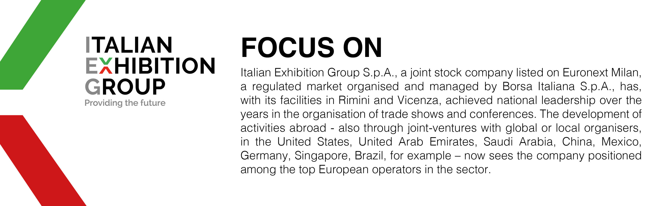

This press release contains forecast elements and estimates that reflect the management’s current opinions (“forward-looking statements”), particularly regarding future management performance, realization of investments, cash flow trends and the evolution of the financial structure. For their very nature, forward-looking statements have a component of risk and uncertainty, as they depend on the occurrence of future events. The effective results may differ (even significantly) from those announced, due to numerous factors, including, only by way of example: food service market and tourist flow trends in Italy, gold and jewellery market trends, green economy market trends; the evolution of raw material prices; general macroeconomic conditions; geopolitical factors and evolutions in the legislative framework. Moreover, the information contained in this release does not claim to be complete, and has not been verified by independent third parties. Forecasts, estimates and objectives contained herein are based on the information available to the Company as at the date of this release.

