

press release
(English translation)

TTG OBSERVATORY: LUXURY AND FOREIGN VISITORS ARE DRIVING SUMMER TOURISM
- With 26% of preferences, Italy comes second among the most desired luxury destinations, surpassing France and trailing Spain, which leads the ranking with 30%.
- Hoteliers report positive results for incoming US tourism: «In the spring period, growth compared to 2024 exceeded double digits." And apropos last-minute bookings: "It has now become a structural trend».
- The trends for the summer season: experience takes precedence over destination, along with multigenerational travel and nature-based activities.
- Tourism and hospitality will take centre stage at TTG Travel Experience and InOut | The Hospitality Community, the industry’s global B2B event, to be held at Rimini Expo Centre from October 8 to 10.
ttgexpo.it | inoutexpo.it
Rimini (Italy) 16 June 2025 - The Italian summer will be driven by luxury tourism and an increase in international visitors, with a significant contribution from the United States. Last-minute bookings remain a stable trend, while experiences, nature, and multigenerational travel are driving new travel preferences. This is the snapshot from TTG Monitor, the TTG Travel Experience Observatory – the international tourism marketplace of Italian Exhibition Group, scheduled to take place from October 8 to 10 at Rimini Expo Centre.
THE DATA: ITALY REMAINS A COMPETITIVE DESTINATION
According to TTG Monitor, Italy continues to be seen as a competitive destination, particularly abroad. This is confirmed by 70% of foreign buyers surveyed (compared to 30% of Italians) who identify a better quality/price ratio in high-end fashion shopping (76%) and typical local products (74%) as strengths. In terms of transportation, the railway system (63%) receives the highest approval. But there's more: 37% of foreign buyers surveyed said they would be willing to spend more than in the past. This trend was already observed in 2024, according to the ISTAT Travel Innovation Observatory, when growth in foreign tourism (251 million visits, +7.4%) offset the decline in domestic tourism (-2.9% for 196 million visits). According to a ranking by Condé Nast Johansens, luxury destinations are primarily driving the industry. In 2025, Italy made a significant leap forward: the report shows that our country surpassed France, ranking second among the most sought-after luxury destinations with 26% of preferences, trailing only Spain (30%) and leaving Portugal and the USA (16%) behind. According to hotel chains, the United States was the main concern ahead of the summer tourist season. However, at TTG Italia, major groups like Omnia Hotels, HNH, Delphina Hotels, and FH55 Hotels have reiterated: «The market is holding up well, and for now, we are not affected by Trump's policies. In fact, in some cases, the incoming US in the spring period has already seen double-digit growth in volumes compared to 2024».
Finally, analysing the summer tourism prospects more broadly, it is true that the luxury segment includes individuals with an average declared income of €85,000 and a holiday budget of over €8,000. This year, according to the Jetcost report, the average budget of Italians will be €1,145, with 77% planning to stay in Italy. The top 3 most popular destinations are Lampedusa, Rome, and Jesolo. However, the last-minute trend continues to grow, described by hoteliers interviewed by TTG Italia as a «structural trend». That's why we don't have specific discount policies, but it's equally true that, well aware of this phenomenon, we offer the option to cancel without penalties, even on the day of arrival.
THE TRENDS OF NEW TRAVELERS
Among the buyers interviewed in TTG Monitor, several increasingly popular trends have emerged. The value of the experience is more important than the choice of destination, as confirmed by 72% of Italian buyers. Additionally, for 69% of foreigners, holidays are becoming an opportunity to reconnect with nature, and 72% report an increase in multigenerational trips where grandparents, parents, and children come together. These themes will be explored in the next edition of TTG, starting with luxury, thanks to the Luxury Event by TTG scheduled at the Grand Hotel in Rimini on October 7 – the day before the show begins. This event, which in 2024 recorded over 1,400 business meetings, promises to be a highlight of the upcoming edition.
In parallel with TTG, InOut | The Hospitality Community, an essential event for those who design, furnish, and renovate tourist accommodation spaces. Here, hotels, hotel chains, architects, designers, general contractors, campsites, beach resorts, and construction companies can find the most cutting-edge solutions. For the 2025 edition, there will be three focus areas: well-being, which integrates wellness, physical and mental regeneration, sports, and food; sports and fitness, increasingly central to the modern tourist experience; and technology, the key to smart hospitality designed to simplify life for both guests and managers.

ABOUT TTG TRAVEL EXPERIENCE – INOUT | The Hospitality Community
Event type: international event; organiser: Italian Exhibition Group SpA; recurrence: annual; edition: 62nd ; open to: exclusively for professional operators; website: www.ttgexpo.it - #ttgexpo

IEG PRESS CONTACTS, TTG TRAVEL EXPERIENCE
Elisabetta Vitali, head of corporate communication & media relations; Marco Forcellini, Pier Francesco Bellini, press office manager, Silvia Giorgi international press office coordinator
media@iegexpo.it

MEDIA AGENCY TTG TRAVEL EXPERIENCE
Martina Vacca: martina@mindthepop.it, mob. +39 339 748 4994; Fabrizio Raimondi: fabrizio@mindthepop.it, mob. +39 335 389 848; Benedetto Colli: benedetto@mindthepop.it, mob. 380 371 2272; Stefano Chiossi: stefano@mindthepop.it, mob. + 39 388 739 4358.

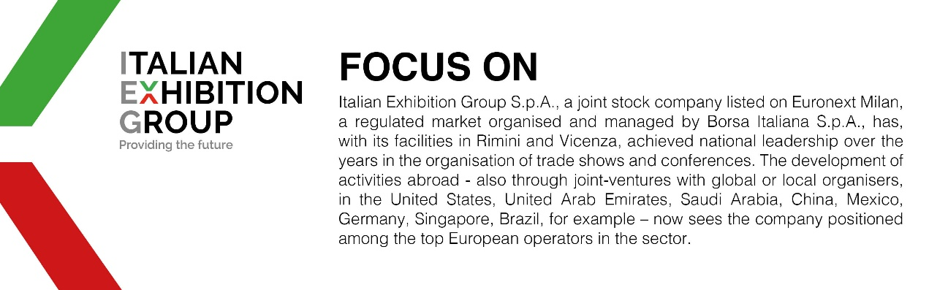

This press release contains forecast elements and estimates that reflect the management’s current opinions (“forward-looking statements”), particularly regarding future management performance, realization of investments, cash flow trends and the evolution of the financial structure. For their very nature, forward-looking statements have a component of risk and uncertainty, as they depend on the occurrence of future events. The effective results may differ (even significantly) from those announced, due to numerous factors, including, only by way of example: food service market and tourist flow trends in Italy, gold and jewellery market trends, green economy market trends; the evolution of raw material prices; general macroeconomic conditions; geopolitical factors and evolutions in the legislative framework. Moreover, the information contained in this release does not claim to be complete, and has not been verified by independent third parties. Forecasts, estimates and objectives contained herein are based on the information available to the Company as at the date of this release.

