Press release no. 1
TOURISM TRANSFORMED: AI, NEW BUSINESS MODELS, AND HOSPITALITY SHAPING THE FUTURE AT TTG TRAVEL EXPERIENCE
- From October 8 -10, Rimini Expo Centre transforms into Italy's largest marketplace for tourism and hospitality with TTG Travel Experience and InOut | The Hospitality Community: 26 halls, 2,700 exhibiting brands, 1,000 buyers from 75 countries, and three days to spot the next big trends in global tourism.

- Luxury Event on October 7: a B2B gathering focused on high-end tourism to redefine the luxury traveller’s experience.

- Destinations and major brands in the spotlight: from Italy to global destinations, including nautical tourism and the new Hotel Chains route dedicated to hotel chains.

www.ttgexpo.it | www.inout.it
Rimini, 01 October 2025 –The tourism and hospitality industry gathers in Rimini from October 8-10, TTG Travel Experience and InOut | The Hospitality Community, at two events curated by Italian Exhibition Group that will transform Rimini Expo Centre into the hub of international tourism business. With 2,700 exhibiting brands across 26 halls and 1,000 buyers from 75 countries, TTG and InOut shine a spotlight on the future of tourism: three days to connect, share ideas, and turn them into business.
"Awake to a New Era" is the theme that will guide the 62nd edition of TTG Travel Experience and InOut | The Hospitality Community. It invites us to recognize the major changes underway—from AI to new global balances—and transform them into concrete strategies for the tourism industry.
On October 8 at 4:30 PM, TTG Travel Experience will unveil the world premiere of Travel & Hospitality Vision +26 by TTG. This report traces the Deep Trends for 2026-2030 and anticipates the challenges the industry will face over the next five years, including new business models, positive-impact tourism, and the increasing integration of artificial intelligence in travel planning.
LUXURY EVENT: EXCLUSIVE PREVIEW
For the third year running, Luxury Event by TTG returns on October 7, set against the backdrop of the Grand Hotel Rimini. The B2B event, which this year brings together 80 exhibitors and 85 top international buyers, will host a day of tailored, high-profile meetings. Today’s luxury traveller seeks authentic experiences made seamless by technology, and Luxury Event by TTG becomes the premier venue for devising strategies to meet these new expectations.
DESTINATIONS, HOTEL CHAINS AND INNOVATIVE COMPANIES: THE HEART OF TTG
The expo centre transforms into a true map of global tourism: from Area Italia, with its seven halls serving as the largest marketplace for incoming tourism, to The World, the "destination hall" where countries from all continents meet the Italian market, and finally the Global Village, the B2B marketplace for tour operators, transportation, and distribution services. Among the special projects not to be missed is Nautical Tourism, an area entirely dedicated to the maritime industry: from charters to cruises, from marinas to coastal reserves, a space that celebrates maritime experiences and those who make them possible. And once again, the African Village returns, showcasing operators and destinations in sub-Saharan Africa. 2025 also marks the debut of Hotel Chains, a multi-location exhibition itinerary highlighting the most prominent national and international hotel chains. Dedicated panels, digital visibility, and exclusive content transform the visit into a journey through the leading hotel brands, offering the opportunity to learn about their development strategies and network in dedicated arenas.
There's also room for innovation with TTG Next Startup, the district that this year hosts 60 Italian and European startups. Here, in the TTG Next Start Up Arena, the TTG Next 2025 Award will also be presented to the most innovative projects in the industry.
ABOUT TTG TRAVEL EXPERIENCE – INOUT | The Hospitality Community
Event: international trade show; organiser: Italian Exhibition Group SpA; frequency: annual; edition: 62nd; open to: trade only; website: www.ttgexpo.it www.inoutexpo.it
PRESS CONTACT IEG, TTG TRAVEL EXPERIENCE
Elisabetta Vitali, head of corporate communication & media relation; Marco Forcellini, Pier Francesco Bellini, press office manager
media@iegexpo.it
MEDIA AGENCY TTG TRAVEL EXPERIENCE
Martina Vacca: martina@mindthepop.it, mob. +39 339 748 5994; Fabrizio Raimondi: fabrizio@mindthepop.it, mob. +39 335 389 848; Benedetto Colli: benedetto@mindthepop.it, mob. 380 371 2272; Stefano Chiossi: stefano@mindthepop.it, mob. + 39 388 739 4358.

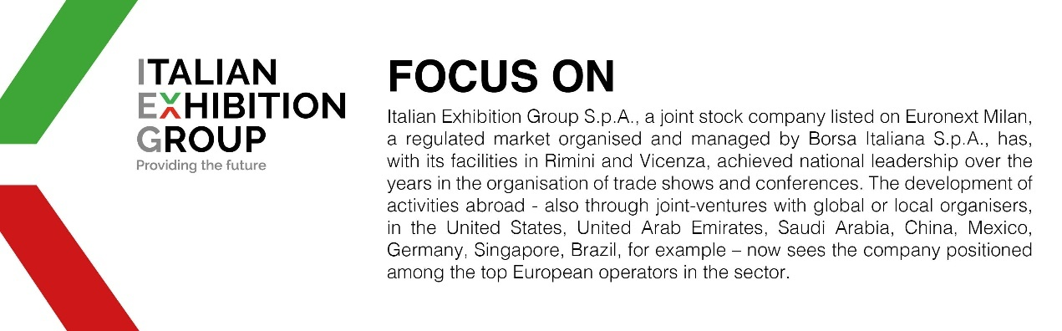

This press release contains forecast elements and estimates that reflect the management’s current opinions (“forward-looking statements”), particularly regarding future management performance, realization of investments, cash flow trends and the evolution of the financial structure. For their very nature, forward-looking statements have a component of risk and uncertainty, as they depend on the occurrence of future events. The effective results may differ (even significantly) from those announced, due to numerous factors, including, only by way of example: food service market and tourist flow trends in Italy, gold and jewellery market trends, green economy market trends; the evolution of raw material prices; general macroeconomic conditions; geopolitical factors and evolutions in the legislative framework. Moreover, the information contained in this release does not claim to be complete, and has not been verified by independent third parties. Forecasts, estimates and objectives contained herein are based on the information available to the Company as at the date of this release.

