Press release no. 2
TRAVEL EXPERIENCE 2025: A PACKED AGENDA TO UNDERSTAND WHERE TOURISM IS HEADING
- Seven arenas, over 200 events, and more than 400 experts: three days of talks, panels, and discussions to explore the changing landscape of tourism at TTG Travel Experience, from October 8 to 10 at Rimini Expo Centre.

- Technology, training, and new trends: from AI to catering, and from hospitality strategies to destination policies.
www.ttgexpo.it | www.inout.it
Rimini, 01 October 2025 – TTG Travel Experience, curated by IEG – Italian Exhibition Group, returns from October 8-10 at Rimini Expo Centre and becomes the laboratory for the tourism of the future. Over 200 events across 7 themed arenas, featuring more than 400 speakers from institutions, businesses, and universities, to explore artificial intelligence, hospitality, catering, sustainability, and training.
ARTIFICIAL INTELLIGENCE AND NEW TECHNOLOGIES
The theme of innovation is at the heart of the programme. At the Global Village Arena (October 8, 11:00-12:00), the event "What AI Can't Do," organised by FTO and CartOrange, will explore the human value in organised tourism and the new potential of artificial intelligence. In the afternoon, (2:30-3:30 PM), the "AI Era" session will further explore the role of the human component in organised tourism.
At the Italy Arena (October 8, 4:50-6:00 PM), an in-depth discussion on audio and video in digital communication is scheduled, titled "AI for Audio and Video: How to Develop Effective Themes and Content in the New Era of Communication." Meanwhile, on October 10 in the Main Arena (11:00 AM-12:00 PM), the conference "The Era of Digital Awareness. Neuro-pricing and psychological strategies to enhance prices” will take place. At the same time, at the Global Village Arena, there will be a practical session titled "ChatGPT for Your Business," aimed at helping tourism companies optimise their time and processes.
THE FUTURE OF TOURISM LIES IN TRAINING
The transformation of tourism also involves the people who experience and manage it. Innovating with technology and new business models is not enough: we need up-to-date skills and professionals who can understand the new needs of travellers and guide businesses and destinations in an increasingly complex global context. In this context, the panel "Is there a new era for tourism?" (October 8, 12:10-13:10, Italy Arena), organised by Simtur, Bocconi, Unigenova, Campus University, and the University of Gastronomic Sciences of Pollenzo, will focus on the skills needed for the future of hospitality, territorial marketing, and sustainable destination management.
GASTRONOMY, SUSTAINABILITY, AND NEW TRENDS
On October 8 (Italy Arena, 2:30-3:30 PM), ISNART presents "Future Indicators. Measuring sustainability for a New Era of Tourism," while on October 9 (11:00-12:00), the focus expands to production sites with "Postcards from the Past and Present: Wind Farms, Mines, and Production Sites," in collaboration with Legambiente and AGSM AIM.

On the same day, at the Italy Arena (1:20-2:20 PM), Coldiretti, ENIT, Consorzio Birra Italiana, and FCA-TN will host the talk "The Awakening of the Italian Countryside," a journey through rural areas, water landscapes, and natural lighting to create an authentic Italian-style vacation.
Food takes centre stage with the preview of the FIPE Report (October 8, Main Arena, 2:10-3:10 PM), an opportunity for a discussion between Fipe-Confcommercio, the Regions, and the Ministry of Tourism on how gastronomy can boost the economy of destinations.
At the Global Village Arena (October 8, 3:40-4:40 PM), the panel "The New Era of Nautical Tourism" – featuring AssoNautica, AssoNat-Confcommercio, ASTUNA, and the Ministry of Tourism – will discuss how boat holidays are becoming a significant business segment. Immediately after (4:50-6:00 PM), the "Golf Industry" meeting, organised by Italy Golf & More, AEFI, and MIMIT, will explore the potential for attracting international investment and tourism.
On October 9 (Main Arena, 2:20-3:20 PM), the panel "From Competitors to Allies" will feature Gruppo FS and ENIT discussing integrated transport and infrastructure to make destinations more accessible.
Also on October 9, the editorial team of TTG Italia will honour the key figures who have shaped tourism with their vision and innovation at "TTG Star – Person of the Year 2025" (Global Village Arena, 4:50 PM – 6:00 PM).
ABOUT TTG TRAVEL EXPERIENCE – INOUT | The Hospitality Community
Event: international trade show; organiser: Italian Exhibition Group SpA; frequency: annual; edition: 62nd; open to: trade only; website: www.ttgexpo.it www.inoutexpo.it

PRESS CONTACT IEG, TTG TRAVEL EXPERIENCE
Elisabetta Vitali, head of corporate communication & media relation; Marco Forcellini, Pier Francesco Bellini, press office manager
media@iegexpo.it
MEDIA AGENCY TTG TRAVEL EXPERIENCE
Martina Vacca: martina@mindthepop.it, mob. +39 339 748 5994; Fabrizio Raimondi: fabrizio@mindthepop.it, mob. +39 335 389 848; Benedetto Colli: benedetto@mindthepop.it, mob. 380 371 2272; Stefano Chiossi: stefano@mindthepop.it, mob. + 39 388 739 4358.

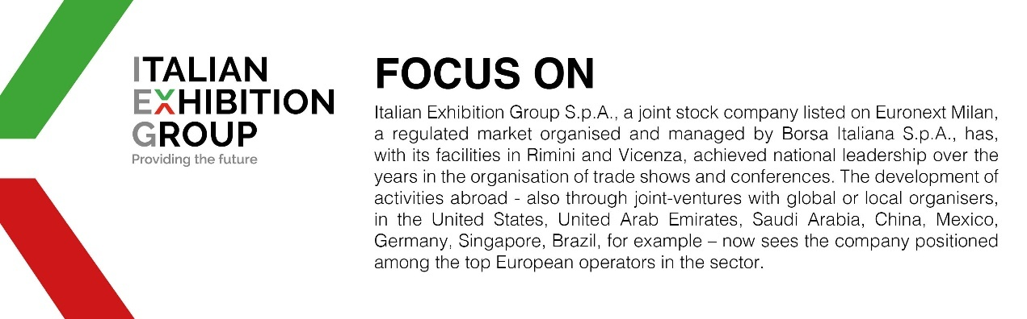

This press release contains forecast elements and estimates that reflect the management’s current opinions (“forward-looking statements”), particularly regarding future management performance, realization of investments, cash flow trends and the evolution of the financial structure. For their very nature, forward-looking statements have a component of risk and uncertainty, as they depend on the occurrence of future events. The effective results may differ (even significantly) from those announced, due to numerous factors, including, only by way of example: food service market and tourist flow trends in Italy, gold and jewellery market trends, green economy market trends; the evolution of raw material prices; general macroeconomic conditions; geopolitical factors and evolutions in the legislative framework. Moreover, the information contained in this release does not claim to be complete, and has not been verified by independent third parties. Forecasts, estimates and objectives contained herein are based on the information available to the Company as at the date of this release.

