Press release no. 4
GROWING TOURISM AND HOTELS AT THE CENTRE: 2025 MARKS A TURNING POINT FOR HOSPITALITY
www.ttgexpo.it | www.inout.it
2025 is shaping up to be one of the most positive years for Italian tourism. According to the annual report by SRM-Intesa Sanpaolo study centre "Tourism and Territory - Trends, impacts, and business dynamics”, tourist numbers could exceed 481 million, up 3.3% from 2024. This growth is primarily driven by foreign visitors, who alone could account for over 265 million overnight stays (up 4.3% and 5.1%, respectively).
FOCUS ON ITALY
The provisional ISTAT data for the second quarter of 2025 confirm the positive trend: overnight stays in accommodation facilities increased by 4.7%, while arrivals rose by 1.1% compared to the same period in 2024. Both Italian tourists (+3.0%) and, more significantly, foreign tourists (+5.9%), who account for over 60% of the total visitors, are performing well.
The analysis by destination type shows particularly strong performance for mountain towns (+12%), stable results for seaside locations (+0.7%), with excellent results in the Romagna Riviera, Veneto, and Friuli-Venezia Giulia. Art cities are also growing, with Milan, Florence, and Bologna all exceeding +8%. In contrast, Venice experienced a 6.1% decline.
According to Assoturismo-CST, the summer season concluded with over 215 million overnight stays, marking a slight increase (+0.2%) from 2024. This growth was primarily driven by international visitors (+2.8%), who offset the decline in Italian visitors (-2.5%). Countryside/hill destinations (+5.5%), mountain destinations (+5.2%), and lake destinations (+3.6%) are on the rise, while seaside destinations have seen a decline of -1.2%.
HOTELS, RESTAURANTS, AND ECONOMIC IMPACT
2025 is set to be a year of momentum for the entire tourism industry, with nearly 477 million visitors expected (+2.3% compared to 2024), over 106 billion euros in added value, and a Hotels and Restaurants industry that is growing by 1.6% compared to last year and 25.6% compared to 2019 (SRM – Intesa Sanpaolo, "Tourism & Territory" Report 2025).
The real driver of this expansion is the hotel industry, which is undergoing a transformation: 64% of hotel companies have invested more than 15% of their turnover in the last three years, and nearly one in two plans new investments in the 2025-2027 period, focusing on sustainability, energy efficiency, digitalisation, and service quality.
This evolution is the main theme at TTG Travel Experience 2025, which places a special focus on the new era of hospitality. A conference with young hoteliers, organised in collaboration with Federalberghi, is planned, along with a round table discussion on the hotel industry to explore its challenges and opportunities. There will be Hotel Talks with key players and a contest for industry startups, culminating in a final award ceremony. The Main Arena will also feature gastronomy, with a preview of the Fipe Report and a discussion on new business opportunities for tourist destinations.
SHORT-TERM AND NON-HOTEL RENTALS
After years of steady growth, the summer of 2025 marks a slowdown in short-term rentals. The average occupancy rate of tourist rentals has dropped to 64%, compared to 65% in the previous two seasons and 66.3% in 2022 (Aigab, summer 2025).
According to Aigab, the issue is not just a weaker demand but also a reduced supply: many owners prefer to use their second homes for themselves, especially on weekends, keeping their listings online but reducing actual availability. Active listings have decreased from over 520,000 to around 508,000, marking a 2.3% decline. Puglia is growing but with lower prices, Sardinia remains stable, while declines have been recorded in Liguria and Campania. Travelers are shortening their stays, opting for the low season, or focusing on foreign destinations like Greece and Spain.
CHANGING HABITS
Operators are noticing a shift in travel habits: average stays are getting shorter, there's a growing trend to spread holidays throughout the year, and there's an increased focus on low-season periods, which are becoming prime opportunities to explore less crowded destinations.
2025 TRAVEL TRENDS
The contemporary traveller is increasingly an "Everything Traveller," adept at combining traditional and trendy destinations, alternating between relaxation and fun, and relying more on online communities than on travel advisors. According to the SiteMinder Changing Traveller Report 2025, 69% of Italians are willing to pay more for eco-friendly facilities.
The use of travel agencies is increasing (+1.5%), especially for packages and organised trips. Meanwhile, workations – working while on holiday – have become a well-established phenomenon, with 35% of Italians bringing their laptops even on holiday.
Technology is becoming a travel ally: 67% of tourists have already used artificial intelligence to plan or book their holidays, and for one in four, AI is now a more authoritative source of inspiration than influencers.
However, there are signs of caution: Federalberghi reports a decline in Americans and Germans visiting seaside destinations, offset by the resilience of the domestic market and the excellent performance of mountain destinations.

ABOUT TTG TRAVEL EXPERIENCE – INOUT | The Hospitality Community
Event: international trade show; organiser: Italian Exhibition Group SpA; frequency: annual; edition: 62nd; open to: trade only; website: www.ttgexpo.it www.inoutexpo.it
PRESS CONTACT IEG, TTG TRAVEL EXPERIENCE
Elisabetta Vitali, head of corporate communication & media relation; Marco Forcellini, Pier Francesco Bellini, press office manager
media@iegexpo.it
MEDIA AGENCY TTG TRAVEL EXPERIENCE
Martina Vacca: martina@mindthepop.it, mob. +39 339 748 5994; Fabrizio Raimondi: fabrizio@mindthepop.it, mob. +39 335 389 848; Benedetto Colli: benedetto@mindthepop.it, mob. 380 371 2272; Stefano Chiossi: stefano@mindthepop.it, mob. + 39 388 739 4358.

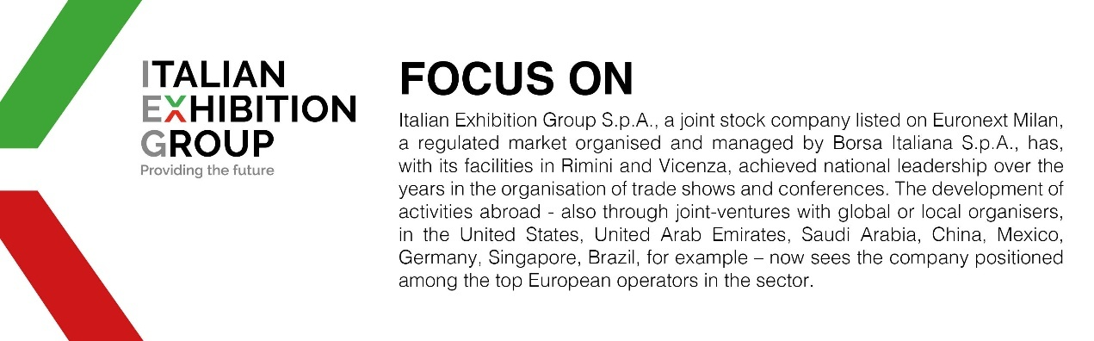

This press release contains forecast elements and estimates that reflect the management’s current opinions (“forward-looking statements”), particularly regarding future management performance, realization of investments, cash flow trends and the evolution of the financial structure. For their very nature, forward-looking statements have a component of risk and uncertainty, as they depend on the occurrence of future events. The effective results may differ (even significantly) from those announced, due to numerous factors, including, only by way of example: food service market and tourist flow trends in Italy, gold and jewellery market trends, green economy market trends; the evolution of raw material prices; general macroeconomic conditions; geopolitical factors and evolutions in the legislative framework. Moreover, the information contained in this release does not claim to be complete, and has not been verified by independent third parties. Forecasts, estimates and objectives contained herein are based on the information available to the Company as at the date of this release.

