*Press release no. 6*

**TTG 2025 LAYOUT**

[www.ttgexpo.it](http://www.ttgexpo.it) | [www.inout.it](http://www.inout.it)

**TTG Travel Experience 2025** spans **14 halls** in the West wing of Rimini Expo Centre, hosting all the Italian regions, major institutional bodies, and international destinations, along with tour operators, hotel chains, and tourism service providers.

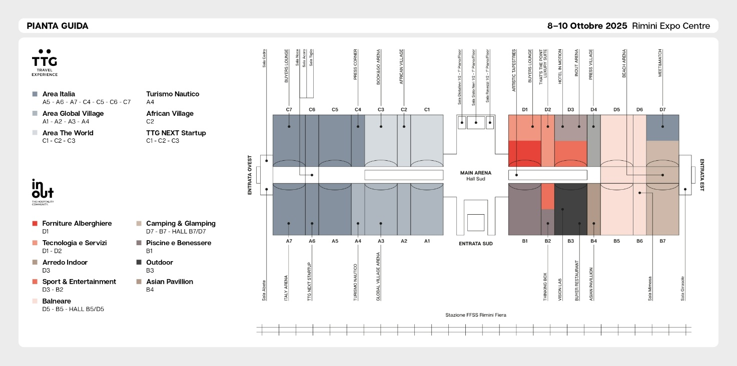

**AREA DIVISION**

**Global Village (A1-A2-A3-A4)**

The beating heart of the B2B business, it hosts tour operators, distribution networks, transport carriers, travel tech companies, and tourism products and services. It is the place where technology and innovation converge, and strategic partnerships for the supply chain are forged.

**Italy (A5-A6-A7-C4-C5-C6-C7)**

The largest national tourism hub: here, regions, DMOs, and consortia showcase the best of Italy, from beach destinations to art cities, from walks to villages, and from food and wine to active tourism. The focus on **nautical tourism** returns to **Hall C4**: from charters to cruises, and from marinas to coastal reserves, this space is designed to highlight the companies that facilitate maritime experiences.

**The World (C1-C2-C3)**The area that brings together the main international destinations interested in developing business with the Italian market. A hub to discover emerging destinations, strengthen relationships with major players in outbound tourism, and create innovative packages. Hall C2, also houses the **African Village**: a collective area that showcases all operators and destinations specialising in sub-Saharan Africa.

Moving on to the Arenas, the Main Arena is located in the south hall, spanning both events (TTG and INOUT).

In **Hall A6**, all 60 innovative startups participating in TTG NEXT Startup will be showcased. This innovation lab, dedicated to startups, will feature a contest and awards for the best ideas and solutions in the tourism industry, taking place in the **TTG Next Startup** Arena.  
Among the **2025 innovations, Hotel Chains** is a project entirely dedicated to hotel chains, unfolding as an exhibition path across various halls. A meeting point for investors, property managers, and industry professionals, featuring talks and workshops on the new era of hospitality.

**ABOUT TTG TRAVEL EXPERIENCE – INOUT | The Hospitality Community**

**Event**: international trade show; **organiser**: Italian Exhibition Group SpA; **frequency**: annual; **edition**: 62nd; **open to**: trade only; **website**: [www.ttgexpo.it](http://srvcww.dominio-fiera.local/gestionecww/template/%C2%B4http:/www.ttgexpo.it) [www.inoutexpo.it](http://www.inoutexpo.it)

**PRESS CONTACT IEG, TTG TRAVEL EXPERIENCE**

Elisabetta Vitali, head of corporate communication & media relation; Marco Forcellini, Pier Francesco Bellini, press office manager

[media@iegexpo.it](mailto:media@iegexpo.it)

**MEDIA AGENCY TTG TRAVEL EXPERIENCE**

Martina Vacca: [martina@mindthepop.it](mailto:martina@mindthepop.it), mob. +39 339 748 5994; Fabrizio Raimondi: [fabrizio@mindthepop.it](mailto:fabrizio@mindthepop.it), mob. +39 335 389 848; Benedetto Colli: [benedetto@mindthepop.it](mailto:benedetto@mindthepop.it), mob. 380 371 2272; Stefano Chiossi: [stefano@mindthepop.it](mailto:stefano@mindthepop.it), mob. + 39 388 739 4358.

This press release contains forecast elements and estimates that reflect the management’s current opinions (“forward-looking statements”), particularly regarding future management performance, realization of investments, cash flow trends and the evolution of the financial structure. For their very nature, forward-looking statements have a component of risk and uncertainty, as they depend on the occurrence of future events. The effective results may differ (even significantly) from those announced, due to numerous factors, including, only by way of example: food service market and tourist flow trends in Italy, gold and jewellery market trends, green economy market trends; the evolution of raw material prices; general macroeconomic conditions; geopolitical factors and evolutions in the legislative framework. Moreover, the information contained in this release does not claim to be complete, and has not been verified by independent third parties. Forecasts, estimates and objectives contained herein are based on the information available to the Company as at the date of this release.