Press release no. 7
HOSPITALITY IN THE SPOTLIGHT: TTG AND INOUT SHINE A LIGHT ON THE HOTEL INDUSTRY
- Hotel Chains makes its debut at the event: an exhibition dedicated to leading Italian and international hotel chains, showcasing new hospitality concepts and industry development projects.

- Hotel Talks: Brands Take the Floor: two days of talks with over 40 hotel groups sharing their visions, strategies, and success stories.

- Debates and training for the future of hospitality: from the AI challenge in the Main Arena to workshops on marketing, digitalisation, and hotel profitability.
www.ttgexpo.it | www.inout.it
Rimini, 01 October 2025 – 2025 is the year to boost the hotel industry: investments in growth, artificial intelligence, and new skills to redefine the hospitality experience. In this context, TTG Travel Experience and InOut | The Contract Community place hospitality at the forefront, making the hotel industry the central theme of an edition designed to inspire and provide practical tools for professionals.
FOCUS ON HOTEL CHAINS
This year's big news is Hotel Chains, an exhibition dedicated to the leading Italian and international hotel chains. It will offer maximum visibility and allow visitors to discover the brands present.
An itinerary transforming the visit into a true journey through the offerings of the chains, exploring development projects, new hospitality concepts, and evolving business models.

HOTEL TALKS: HOTELS TELL THEIR STORIES
Next to the exhibition area, Hotel Talks become the heart of the hospitality narrative.
The agile format gives each chain 30 minutes on stage to present their vision, development projects, technological innovations, and new guest experience concepts.
The event will take place in Sala Tiglio 2 on October 8 and 9, featuring two days of engaging speeches designed to capture the attention of the professional audience and promote networking among industry professionals.
These are not just presentations, but storytelling and interactive sessions where leading brands share their experiences, success stories, and strategies for the future.
More than 40 hotel groups have already signed up. Among the key participants in the Hotel Talks will be BWH Hotel Italia & Malta, Falkensteiner, Planetaria Hotels, B&B Hotels, Piazza Hotels, Bzar Hotels, Omnia Hotels, a&o Hostel, Belstay Hotels, and CDSHotels.
THE HOSPITALITY CHALLENGE: STRATEGIC VISION AND CONCRETE SOLUTIONS AT THE FAIR
The discussion on the future of hospitality kicks off on October 8 in the Main Arena with one of the most highly anticipated events: "The new era of hospitality: advantages and obstacles. Is AI outpacing the industry players?”: A discussion among the top managers of Planetaria Hotels, Grand Hotel et de Milan, Accor, and Lindbergh Hotels, who will explore how to turn artificial intelligence from a challenge into an opportunity, while staying competitive and in line with the expectations of increasingly digital travelers. The focus on the hotel industry also extends to the event arenas, where talks and round tables are scheduled to

discuss the new era of hospitality, the role of AI for hotels and destinations, and the training of new tourism professionals. The programme continues by outlining two complementary paths for those working in the hotel industry. On one hand, there are sessions dedicated to strategic vision, designed to help operators integrate marketing, communication, and revenue management, reposition their structures, and attract new audiences. On the other hand, there are more practical sessions that delve into digital strategies, offer diversification, and explore tools to enhance profitability and strengthen facility management.

ABOUT TTG TRAVEL EXPERIENCE – INOUT | The Hospitality Community
Event: international trade show; organiser: Italian Exhibition Group SpA; frequency: annual; edition: 62nd; open to: trade only; website: www.ttgexpo.it www.inoutexpo.it
PRESS CONTACT IEG, TTG TRAVEL EXPERIENCE
Elisabetta Vitali, head of corporate communication & media relation; Marco Forcellini, Pier Francesco Bellini, press office manager
media@iegexpo.it
MEDIA AGENCY TTG TRAVEL EXPERIENCE
Martina Vacca: martina@mindthepop.it, mob. +39 339 748 5994; Fabrizio Raimondi: fabrizio@mindthepop.it, mob. +39 335 389 848; Benedetto Colli: benedetto@mindthepop.it, mob. 380 371 2272; Stefano Chiossi: stefano@mindthepop.it, mob. + 39 388 739 4358.

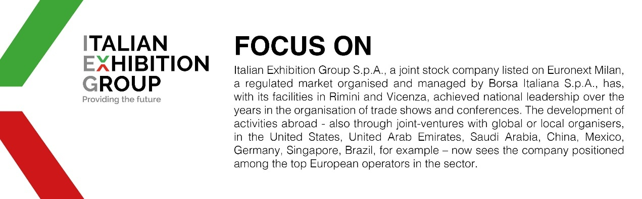

This press release contains forecast elements and estimates that reflect the management’s current opinions (“forward-looking statements”), particularly regarding future management performance, realization of investments, cash flow trends and the evolution of the financial structure. For their very nature, forward-looking statements have a component of risk and uncertainty, as they depend on the occurrence of future events. The effective results may differ (even significantly) from those announced, due to numerous factors, including, only by way of example: food service market and tourist flow trends in Italy, gold and jewellery market trends, green economy market trends; the evolution of raw material prices; general macroeconomic conditions; geopolitical factors and evolutions in the legislative framework. Moreover, the information contained in this release does not claim to be complete, and has not been verified by independent third parties. Forecasts, estimates and objectives contained herein are based on the information available to the Company as at the date of this release.

